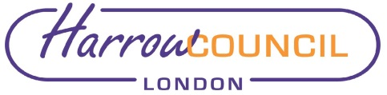

REPORT FOR: |  | COUNCIL
 | Date of Meeting: |  | 16 January 2020
 | Subject: |  | DECISIONS TAKEN UNDER THE URGENCY PROCEDURE - COUNCIL
 | Responsible Officer: |  | Hugh Peart – Director of Legal and Governance Services
 | Exempt: |  | No
 | Enclosures: |  | None

In accordance with the delegations to Chief Officers, the Leaders of each of the Political Groups on the Council were consulted on the following urgent decision, which was approved on behalf of the Council, on the date below as it required action prior to this meeting.

22 August 2019 - Appointments to Outside Bodies

Following a resignation, an appointment to an Outside Body of the Council was agreed as follows:

West House and Heath Robinson Museum Trust – Councillor Paul Osborn

This appointment was agreed as a matter of urgency to ensure continuing Council representation on this body at the earliest opportunity.

4 December 2019 – Attendance at Council meetings

It was agreed that the calling of the Parliamentary General Election on 12 December 2019 be a valid reason under Section 85 (1) of the Local Government Act 1972 why any Councillor may not be able to meet the requirement to attend a meeting within a six month period ending on 31 January 2020.

FOR INFORMATION

Contact:
Elaine McEachron, Democratic & Electoral Services Manager
Tel: 020 8424 1097
E-mail: elaine.mceachron@harrow.gov.uk

Background Papers: Urgent Decision Forms.

